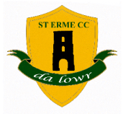

St Erme Cricket Club
Nick Cole – Hon Secretary
Email – nickandhelen25@btinternet.com
www.sterme.play-cricket.com
Home – 01872 270805

St Erme Cricket Club joined the Cornwall League in 1992 and we currently run two Saturday teams in Cornwall County 1 and division 4 East as well as a more social side on a Wednesday evening. We have a thriving Junior Section which meets on Monday evenings during the summer months between 6:30pm and 8pm.

First Team Captain for 2018 – Tom Bunt
Second Team Captain for 2018 – Andy Wilkinson
Youth Development Officer – Dave Moses

All enquiries welcome via the Secretary – details above.

